Hellknights
The letter of the law is absolute—and lest all civilization fall to dust, its enforcement must be swift and unfailing. None embody this harsh truth more than the Hellknights, an order of warriors dedicated to the protection and progress of society at all costs. The Hellknight organization traces to Cheliax, where nearly 150 years ago a band of vigilantes gained legitimacy from their king. In the decades since, the knighthood has morphed into multiple branches that answer to none but their own vision of consummate law.
Hellknights believe that without their commitment to order, the fabric of existence itself faces jeopardy. Thus, Hellknights are dutiful law enforcers, rooting out those who would undermine order and peace. When anarchy looms, Hellknights are executioners of all things and people who would propagate the tide of chaos. The laws Hellknights defend are not those of a single nation or tyrant, but rather a codex all their own, collected from myriad legal codes throughout history and fortified with the strictures of the most lawful society of planes: Hell itself.
To some Hellknights, the Pit is an enviable ideal; to others, its order paves the way for the cosmos’ most reprehensible realms, and for that alone it must be respected. Regardless of their personal moral codes, Hellknights believe that Hell is the multiverse’s greatest forge, and that those fortified in its flames emerge unbending and unbreakable. Thus, aspiring knights willingly submit to the horrors of Hell, and only those who survive its gauntlet are worthy bearers of the Hellknight title.
Since the order’s founding nearly 150 years ago, tested and inducted Hellknights have co-opted the imagery and inimitable lawfulness of the Pit, wresting it for their own purposes. This fact is most obvious when Hellknights stand blazing and fearsome before their enemies—full Hellknight regalia includes head-to-toe black armor, evoking the epitome of an infernal warrior. Sculpted with stylized spikes and imprinted with emblems of diabolical menace, a Hellknight’s armor denotes to which sect they belong, and it invests them with their order’s full authority and capacity for merciless enforcement.

The Measure and the Chain
All Hellknights enforce and execute the basics of what they call the Measure—the order’s massive collection of laws and strictures—and the Chain, a philosophy concerning itself with three utmost virtues. Order, discipline, and mercilessness make up the three links of the Chain, and each link involves a cornerstone of the philosophy that fuels all of these warriors.
In enforcing order, the Hellknights strive to create a world that is so peaceful and regimented that it has no need for them. Further, the Hellknights’ vision of order encourages each soul to punish those who hold back progress. Discipline teaches that no achievement occurs without loss, and emotions are a distraction at best—and at worst, a vulnerability. This includes fear, which all Hellknights attempt to dutifully master and turn into a weapon against the weak. In practicing perfect discipline, Hellknights prepare themselves to destroy all who would prevent them from accomplishing their goals.
The concept of mercilessness, the Hellknights’ third philosophical link, teaches that all are guilty of some infraction against order, and compassion is damaging to civilization and inhibits social progress. Exceptions to this rule, the Hellknights believe, pave a path to anarchy. As all have transgressed, none are worthy of mercy— including individual Hellknights themselves, who hold themselves to the highest standards of their own tenets.
The Hellknight order’s absolute zealotry toward law and discipline attracts many hopefuls who are cruel and evil at heart, and even some who revere Asmodeus’s wickedness above all else. However, Hellknight members as a whole are not necessarily evil. For those who seek it, there is room for goodness and morality within the Hellknights’ regimented ranks, as long as the Measure’s strictures are upheld. Evil hopefuls often find that while they assume the Hellknights might provide shelter for their wicked deeds, they themselves are too capricious to stand as a paragon of order. In any case, the screams of unsuccessful evil Hellknight hopefuls echo just as loudly throughout a citadel’s halls as do those of the weak and the wanting—and the pits of Hell are happy to welcome all failures into the eternal embrace of the damned.

Arms of Total Law
All Hellknights must pass a simple but brutal test—besting a denizen of Hell in single combat—and adhere to the order’s overarching general philosophies. Beyond these shared elements, separate orders within the knighthood focus on specific aspects of quelling lawlessness and savagery. There are seven major Hellknight orders that roam the Inner Sea region and beyond, many of them based in or near Cheliax, where the organization began. The seven major Hellknight orders are described below. While directly acting in violation of an order’s specific mandate is even more egregious than violating the Measure and the Chain in general, Hellknights don’t tolerate infractions of any kind, no matter how small, and thus the orders don’t list specific anathema.

Order of the Chain
Based in Citadel Gheradesca near Corentyn in Cheliax, the Order of the Chain’s knights are bounty hunters and jailers. They equally hunt bandits, murderers, and fugitives, imprisoning the worst offenders in their fortress-like citadel. These Hellknights specialize in fields such as tracking, criminal psychology, investigation, and interrogation. The order’s favored weapon is the flail.

Order of the Gate
Based in Citadel Enferac just east of Pezzack in Cheliax and consisting of only a few hundred members, the Order of the Gate is the smallest major Hellknight order. It’s also the only order where signifers—Hellknight spellcasters—outnumber rank-and-file knights. These spellcasters use all types of magic to devise new ways to bring law to the world, and they are known for using eldritch rites to sniff out crimes as they are committed or even as they are being planned. The order’s favored weapon is the dagger.

Order of the Godclaw
Based in Citadel Dinyar in the Aspodell Mountains just within Isger’s borders, the Order of the Godclaw is the only Hellknight order to dedicate itself to faith. These Hellknights revere a unique dogma borne from a combination of the most lawful aspects of five lawful deities: Abadar, Asmodeus, Iomedae, Irori, and Torag. These Hellknights follow their doctrine, which they call the Godclaw, to stamp out disorder and oppose the forces of absolute chaos. The order’s favored weapon is the morningstar.

Order of the Nail
Based in Citadel Vraid near Korvosa in Varisia, the Order of the Nail dedicates itself to stamping out threats that lurk within the vast swaths of wilderness that threaten to choke civilized society. These Hellknights see roaming monsters, unchecked superstitions, and unruled frontier living as a threat to society. The Nail often dispatches contingencies of knights throughout the world to deal with what they see as rising threats. The order’s favored weapons are the halberd and lance; Hellknights who travel on foot prefer the halberd, while mounted Hellknights fight with lances.

Order of the Pyre
Based in Citadel Krane near Ostenso in Cheliax, the Order of the Pyre concerns itself with rooting out dangerous religions, seductive perspectives, and revolutionary science that threatens society’s status quo. Members of this order see themselves as cultist hunters and witchcraft persecutors, and they view all faiths beyond the Inner Sea region’s most common religions with suspicion. The order’s favored weapon is the glaive.

Order of the Rack
Based in Citadel Rivad near Westcrown in Cheliax, the Order of the Rack is the enemy of decadent thinking, selfish desire, and fruitless fantasy—all vices they believe inhibit societal growth and progress. Of all the major Hellknight orders, the Rack is most hated due to the order’s reputation for raiding the homes of those who speak out against the status quo. The Rack is also notorious for breaking up groups of malcontents before they become guilds, unions, or revolutionaries. The order’s favored weapons are the longsword and whip.

Order of the Scourge
Based in Citadel Demain near the Chelaxian capital of Egorian, the Order of the Scourge is dedicated to rooting out corrupt individuals and influences within governments and other powerful groups. Its members hunt for political manipulation and abuses of power, and their efforts also include waging an endless war against organized crime. The order’s favored weapons are the mace, scourge (page 80), and whip.

Other Orders
In addition to these major orders, several smaller orders also pursue niche mandates. These are the Order of the Coil, an evil order that persecutes indigenous peoples and historical sites in the Mwangi Expanse; the Order of the Crux, an evil order of undead false Hellknights who have risen as graveknights on the Cheliax-Nidal border; the Order of the Glyph, an evil and illegitimate order that works at the behest of Cheliax’s House Thrune to suppress the nation’s histories and lore; the Order of the Pike, a fearsome group of monster slayers; the Order of the Scar, a group of assassin-hunters who once served the Chelaxian crown; the Order of the Torrent, a goodly organization based in Ravounel dedicated to hunting kidnappers and recovering the kidnapped; and the Order of the Wall, a group subordinate to the Order of the Chain that stands vigil in Khari, the stolen Rahadoumi city that remains in Cheliax’s grasp.

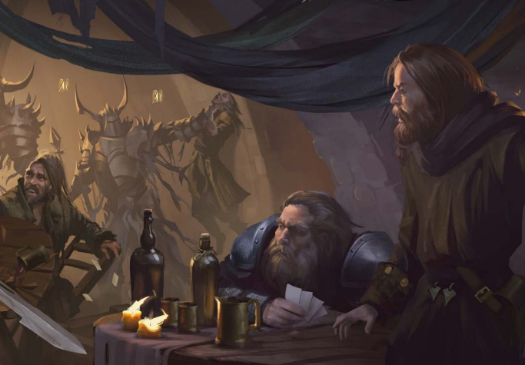

Within the Hellknights
Although each Hellknight order’s unique lore and history are largely opaque to the masses, the general process for becoming a Hellknight is practically common knowledge. Hellknight hopefuls must petition to join an order at that group’s citadel or through the patronage of a serving Hellknight. At this point, a recruit becomes classified as an armiger, and they undergo intensive reeducation and physical training with a member of their chosen order to move forward with their candidacy for knighthood. In some cases, a Hellknight might train their own armiger in the field. Armigers typically train for as long as an overseeing Hellknight believes necessary, though the typical period is about 3 years.
At any point in an armiger’s training—but typically at the behest of a sponsoring or overseeing Hellknight— the armiger may request to take the Hellknight Test. If the candidate passes the test, the armiger becomes a full Hellknight, receives their official armor and weapon of their order, and is invested with all the authority and station their rank confers. If the armiger fails the test, they die, and the order does not mourn them.

The Hellknight Test
The Hellknight Test is simple: an armiger must best an immortal champion of Hell whose power in combat mirrors her own. The test’s specifics differ subtly between orders, but for all of them, the official test is a somber ritual conducted twice each year. A high-ranking officer oversees the test, a signifer administers it in conjuring the devil, and every available member of the order stands witness.
After a lengthy introduction, the armiger in question enters a clearly marked arena. The signifer then conjures the devil, and the two fight to the death. If the armiger prevails, they recite their vows immediately after the battle, as long as their injuries aren’t life threatening. If the armiger dies, the test is over and they fail.
By decree of the Measure, there is one alternate way to achieve knighthood. An armiger can defeat a qualifying devil in single combat outside of the ritual ceremony, but doing so requires a sponsor. If a Hellknight in good standing bears witness to the feat and vouches for them, the armiger can become a member of the order.

Hellknight Titles
Numerous ranks exist within the Hellknight orders, but the following—listed from lowest in authority to highest—are the most pervasive.

Armiger
A Hellknight in training; a Hellknight squire. Armigers are considered affiliated with their respective orders, but they are not full members and have not yet earned their own set of iconic Hellknight armor, nor have they been issued their order’s formal weapon.

Signifer
A Hellknight spellcaster. According to the Measure, signifers rank nominally below rank-and-file Hellknights, who are granted the authority to give orders to spellcasters on the battlefield. The exception to this is the Order of the Gate, which has enacted a rider for its members that elevates its signifers over its Hellknights.

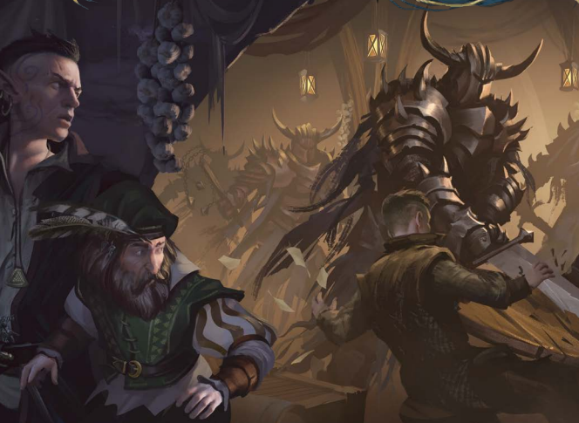

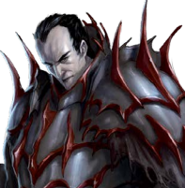
Hellknight
A rank-and-file Hellknight. Hellknights are imbued with the authority to undertake missions, travel and enforce the law in key places (depending on their order’s needs), and make field decisions as necessary to further their objectives. Hellknights wear iconic black full-plate armor and typically wield the signature weapons of their order.

Maralictor
A mid-level Hellknight officer, similar to a lieutenant. Maralictors with titular concerns or duties—such as the relatively common arms-maralictors, field-maralictors, and gate-maralictors—are of lesser rank.

Paralictor
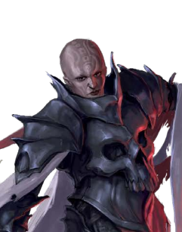
A high-ranking Hellknight officer, similar to a major.

Paravicar
A leader of a Hellknight order’s signifers, equal in rank to a master of blades.

Master, Mistress, or Myx of Blades
A colonel of a Hellknight order, equal in rank to a paravicar.

Vicarius
A spellcasting leader of a Hellknight order, equal in rank to a lictor. This title is rarely used.

Lictor
A general and the highest-ranking member of a Hellknight order.

Local Authorities
Hellknights tend to work alongside local law enforcement when it’s favorable to them, but they take the law into their own hands when they find local authorities lacking.

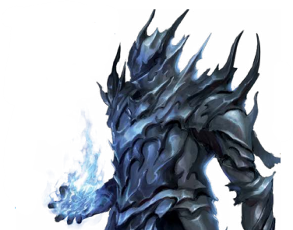
NOTABLE FIGURES

Lictor Uro Adom
The lawful neutral leader of the Order of the Chain, Adom began his career as a constable, eventually became known as the “Panther of Pangolais,” and is the ultimate warden of the fortress-like Citadel Gheradesca

Vicarius Giordano Torchia
The lawful evil leader of the Order of the Gate, Torchia is a brilliant wizard known for his arrogance, his vast network of informants, and his frequent deals with powerful devils.

Lictor Resarc Ountor
The lawful neutral leader of the Order of the Godclaw, Ountor is a former exclusive servant of Abadar who believes deeply in the strength of cooperation, progress in discipline, and glory in eliminating the foes of order.

Lictor Severs “Boneclaw” DiViri
The lawful evil leader of the Order of the Nail, DiViri is utterly committed to his cause, and he is a flawless battlefield tactician in conflicts fought in the wilds.

Lictor Rouen Stought
The lawful neutral leader of the Order of the Pyre, Stought is a staunch atheist who believes all deities are a nuisance, and she would gladly see every temple in Golarion burn.

Lictor Darcyne Wrens
The lawful neutral leader of the Order of the Rack, Wrens is a skilled sorcerer who nonetheless sees wizards as a threat to her order’s cause of quelling insurrection.

Lictor Toulon Vidoc
The lawful neutral leader of the Order of the Scourge, the charming Vidoc has a reputation as one of Cheliax’s greatest detectives, and is also one of the Hellknights’ most politically active and diplomatic leaders.

Bienvenue à Breachill
